# What is a URL?

URL stands for *Uniform Resource Locator*, or in other words, the web address of an online resource, i.e. a web site or document.

# The URL is created in one of two ways

1. after clicking a link in a web page, bookmark or email
2. by typing the URL directly into the address bar

The protocol's connected to the domain name and the domain name's connected to the file path...

Using the URL of this article as an example, the three basic parts of a URL you should understand are the *protocol*, the *domain*

*name* and the *path*.

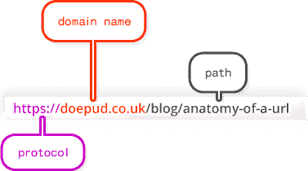

here's an example of a more complex-looking URL:

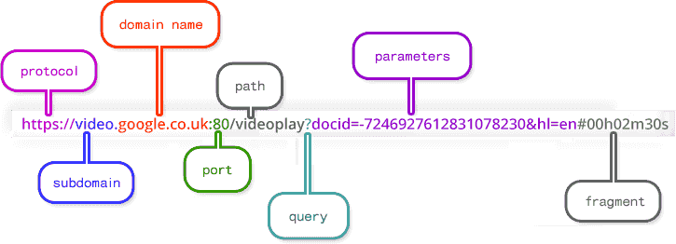

# URL anatomy explained

**Protocol**

The protocol declares how your web browser should communicate with a web server when sending or fetching a web page or document. The most common protocol is http which stands for Hypertext Transfer Protocol.

Another common protocol is https which stands for Hypertext Transfer Protocol Secure. You'll see this on secure pages, like shopping sites and log in pages. If you're visiting a site where you need to enter sensitive information, like bank details and passwords, make sure the protocol is declared as https. This means your web browser encrypts any information you provide so it can't be understood by any phishers who try to intercept the page during transfer.

Some protocols you're less likely to see include ftp (File Transfer Protocol) pop (Post Office Protocol), smtp(Simple Mail Transfer Protocol) and imap (Internet Message Access Protocol). If you want to know more here's a list of protocols.

**Subdomain**

A subdomain is a sub-division of the main domain name. For example, mail.doepud.com and calendar.doepud.com are subdomains of the domain name doepud.com.

**Domain name**

A domain name is a unique reference that identifies a web site on the internet, for example doepud.co.uk. A domain name always includes the top-level domain (TLD), which in Doepud's case is uk. The co part is shorthand for commercial and combined .co.uk is called a second-level domain (SLD).

**Port**

The port number is rarely visible in URLs but always required. When declared in a URL it comes right after the TLD, separated by a colon. When it's *not* declared and in most cases where the protocol is http, port 80 is used. For https (secure) requests port 443 is used.

Read more about port numbers in URLs.

**Path**

The path typically refers to a file or directory on the web server, e.g. /directory/file.php.

Sometimes the file name won't be specified,

e.g. https://doepud.co.uk/blog/ so a web browser will automatically look inside the /blog/ folder for a file called index or default. If neither can be found, a *404 Not Found* error will usually be returned by the server.

**Query**

A query is commonly found in the URL of dynamic pages (ones which are generated from database or user-generated content) and is represented by a question mark followed by one or more parameters. The query directly follows the domain name, path or port number.

For example, have a look at this URL which was generated by Google when doing a search for the word *URL*:

<http://www.google.co.uk/search?q=url&ie=utf-8&oe=utf-> 8&aq=t&rls=org.mozilla:en-GB:official&client=firefox-a.

The query part is

?q=url&ie=utf-8&oe=utf-8&aq=t&rls=org.mozilla:en- GB:official&client=firefox-a.

**Parameters**

Parameters are snippets of information found in the query string of a URL. With reference to the Google query above, the parameters follow the question mark and are separated by an ampersand (&) character so they can be understood individually and used to display content on that page. The parameters are:

* q=url
* ie=utf-8
* oe=utf-8
* aq=t
* rls=org.mozilla:en-GB:official
* client=firefox-a

**Fragment**

A fragment is an internal page reference, sometimes called a *named anchor*. It usually appears at the end of a URL and begins with a hash (#) character followed by an identifier. It refers to a section *within* a web page.

# What is a domain name?

A domain name is your website name. A domain name is the address where Internet users can access your website. A domain name is used for finding and identifying computers on the Internet. Computers use IP addresses, which are a series of number. However, it is difficult for humans to remember strings of numbers. Because of this, domain names were developed and used to identify entities on the Internet rather than using IP addresses.

A domain name can be any combination of letters and numbers, and it can be used in combination of the various domain name extensions, such as .com, .net and more.

The domain name must be registered before you can use it. Every domain name is unique. No two websites can have the same domain name. If someone types in [www.yourdomain.com,](http://www.yourdomain.com/) it will go to your website and no one else's.

# Portal

* 1. *Portal* is a term, generally synonymous with *gateway*, for a World Wide Web site that is or proposes to be a major starting site for users when they get connected to the Web or that users tend to visit as an anchor site. There are general portals and specialized or niche portals. Some major general portals include Yahoo, Excite, Netscape, Lycos, CNET, Microsoft Network, and

America Online's AOL.com. Examples of niche portals include Garden.com (for gardeners), Fool.com (for investors), and SearchNetworking.com (for network administrators).

A number of large access providers offer portals to the Web for their own users. Most portals have adopted the Yahoo style of content categories with a text-intensive, faster loading page that visitors will find easy to use and to return to. Companies with portal sites have attracted much stock market investor interest because portals are viewed as able to command large audiences and numbers of advertising viewers.

Typical services offered by portal sites include a directory of Web sites, a facility to search for other sites, news, weather information, e-mail, stock quotes, phone and map information, and sometimes a community forum. Excite is among the first portals to offer users the ability to create a site that is personalized for individual interests.

|  |  |  |  |
| --- | --- | --- | --- |
| The term *portal space* is | used to mean the total | number of | major |
| sites competing to be one | of the portals. |  |  |

* 1. In fantasy games, science-fiction, and some "New Age" philosophies, a portal is a gateway to another world of the past, present, or future, or to an expanded awareness.
  2. In 3-D graphics development, *portal rendering* is a technique that increases the effect of realism and speeds up presentation.

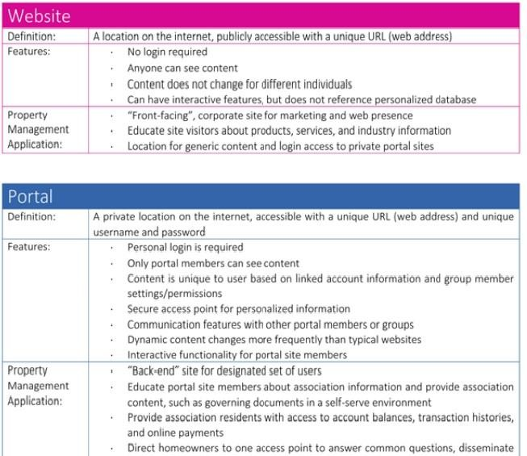

**APPLICATIONS OF E-COMMERCE:**

The applications of E-commerce are used in various business areas such as retail and wholesale and manufacturing. The most common E-commerce applications are as follows:

1. **Online marketing and purchasing**
2. **Retail and wholesale**
3. **Finance**
4. **Manufacturing**
5. **Online Auction**
6. **E-Banking**
7. **Online publishing**
8. **Online booking (ticket, seat.etc)**

# Online marketing and purchasing

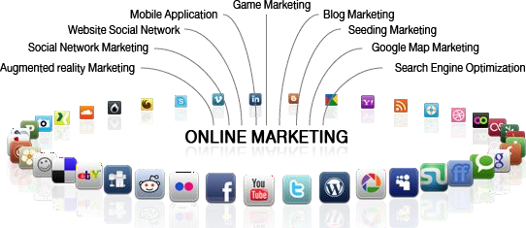

Data collection about customer behavior, preferences, needs and buying patterns is possible through Web and E-commerce. This helps marketing activities such as price fixation, negotiation, product feature enhancement and relationship with the customer.

# Retail and wholesale:

E-commerce has a number of applications in retail and wholesale. E-retailing or on-line retailing is the selling of goods from Business-to-Consumer through electronic storesthat are designed using the electronic catalog and shopping cart model. Cybermall is a single Website that offers different products and services at one Internet location. It attracts the customer and the seller into one virtual space through a Web browser.

# Finance:

Financial companies are using E-commerce to a large extent. Customers can check the balances of their savings and loan accounts, transfer money to their other account and pay their bill through on-line banking or E-banking. Another application of E- commerce is on-line stock trading. Many Websites provide access to news, charts, information about company profile and analyst rating on the stocks.

# Manufacturing:

E-commerce is also used in the supply chain operations of a company. Some companies form an electronic exchange by providing together buy and sell goods, trade market information and run back office information such as inventory control. This speeds up the flow of raw material and finished goods among the members of the business community. Various issues related to the strategic and competitive issues limit the implementation of the business models. Companies may not trust their competitors and may fear that they will lose trade secrets if they participate in mass electronic exchanges.

# Auctions:

Customer-to-Customer E-commerce is direct selling of goods and services among customers. It also includes electronic auctions that involve bidding. Bidding is a special type of auction that allows prospective buyers to bid for an item. For example, airline companies give the customer an opportunity to quote the price for a seat on a specific route on the specified date and time.

# E-Banking:

Online banking or E- banking is an electronic payment system that enables customers of a financial institution to conduct financial transactions on a website operated by the institution, Online banking is also referred as internet banking, e-banking, virtual banking and by other terms.

# Online publishing:

Electronic publishing (also referred to as e-publishing or digital publishing) includes the digital publication of e-books, digital magazines, and the development of digital libraries and catalogs.

# Online booking (ticket, seat.etc)

An **Internet booking engine** (IBE) is an application which helps the travel and tourism industry support reservation through the Internet. It helps consumers to book flights, hotels, holiday packages, insurance and other services online. This is a much needed application for the aviation industry as it has become one of the fastest growing sales channels.